**DEVELOPMENT OF WEBSITE FOR GITAM UNIVERSITY**

Agenda for the application:

The following Application is useful to provide the basic information about GITAM university Hyderabad campus and it is also useful for the institution for several activities like:

1. To get the feedback from the people

2. To make people to sign on to their website

3. To provide several facilities regarding there institution to others by giving access to people by their login page.

Data to be captured:

1. Name

2. Telephone number

3. Email id

4. Date of birth

5. Branch

6. Year of passing

7. Year of admission

8. College ID number

**The following data is captured from the students of GITAM for giving the access to their site.**

**Software Requirements:**

**HTML,CSS and Javascript.**

**UML DIAGRAM**

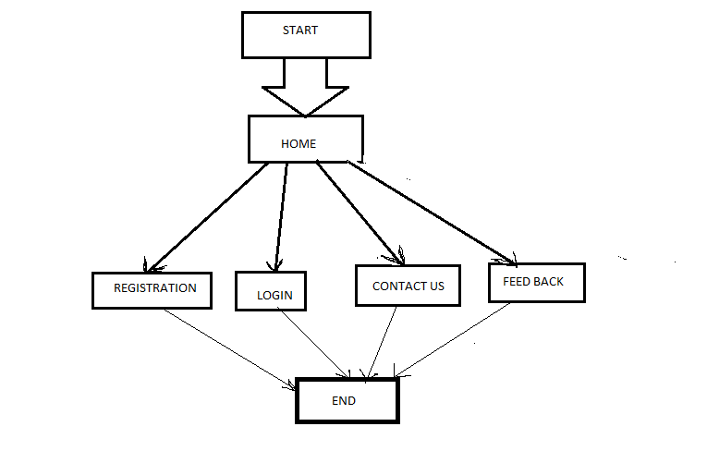

**FRAMEWIRE:**

